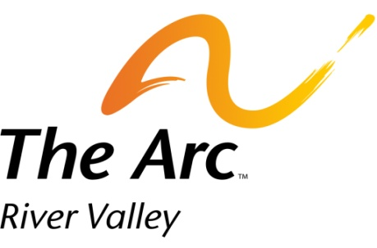

For people with intellectual
and developmental disabilities

Job Description
Marketing and Research Intern

Mission:

The Arc for the River Valley provides advocacy, education, and recreation for those with intellectual and developmental disabilities.

Reports to:

Executive Director

Description:

While reporting to the Executive Director, the Marketing and Research Intern is responsible for developing a marketing and social media plan to cover (at least) a 6 month period, as well as research statistics and ways to advocate for people with disabilities in our state. These tasks are to align with The Arc for the River Valley’s programs, development, expansion, and execution of its mission.

Responsibilities:

- Develop, organize and execute The Arc’s non-profit marketing plan
- Creating and executing a strategy for a large sustained base of marketing for social media and other outlets
- Developing and tracking a database for research and statistics involving advocacy issues for people with intellectual and developmental disabilities in Arkansas
- Ensure effective systems to track progress, and regularly evaluate program components, so as to measure successes that can be effectively communicated to the Executive Director

Qualifications:

The Marketing and Research Intern will be thoroughly committed to The Arc for the River Valley’s mission. Concrete demonstrable experience and other qualifications include:

- Strong computer skills with ability to create and maintain spreadsheets and database files
- Strong written and communication skills with excellent interpersonal and multidisciplinary project skills
- Unwavering commitment to quality programs and data-driven program evaluation
- Set and achieve strategic objectives
- Familiarity of working in public relations and experience in media outlets
- Ability to work effectively in collaboration with diverse groups of people
- Passion, idealism, integrity, positive attitude, and mission-driven

